Ransford S. McCourt, PE, PTOE

6528 SW Alden Street

Portland, OR 97223

May 10, 2021

Stephanie Pollack

Acting Administrator (HOA-1)

Federal Highway Administration

1200 New Jersey Avenue, S.E., West Building W-12-140

Washington, DC 20590

**Subject: Comments on Notice of Proposed Amendment (NPA) for the 11th Edition of the MUTCD**

Dear Acting Administrator Pollack:

I am writing to offer comments on the December 14th NPA for the Manual on Uniform Traffic Control Devices (MUTCD). I have been a professional transportation engineer for over 40 years working extensively with numerous public agencies and private organizations in transportation. I participate in both ITE (serving as their current Past President) and NCUTCD (active on technical committees and several task forces). Thank you for considering my docket comment.

I greatly appreciate FHWA’s effort to undertake the update to the MUTCD. The NPA is greatly needed in the profession today considering the last rule making 13 years ago. The NPA offers significant near-term safety advances for the traveling public based on extensive research. It is timely to advance as soon as possible toward final rule making as these changes are broadly valued. I support the NCUTCD and ITE docket comments. The incorporation of meaningful and thoughtful Docket comments such as those recommended by ITE and the NCUTCD will greatly improve the 11th edition of the MUTCD and bring necessary safety benefits to the traveling public now. I have also offered detailed comments that are achievable with modest edits that can improve the NPA offered changes.

I understand the need to improve the MUTCD related to flexibility (local control), provide timely updates and a full spectrum approach to road users both in terms of modes and context (freeways to local streets). I would support the need to think deeply about the concerns noted by those who wish to stall the NPA and reframe the MUTCD. I believe this best can be accomplished by the timely completion of final rule making on the 11th Edition of the MUTCD and rapidly moving toward full evaluation of content and structure of the subsequent edition(s) of the MUTCD. I know tens of thousands of volunteer hours have been spent to guide FHWA toward a meaningful update to the MUTCD in the last six months and these resources stand ready to support FHWA in re-examining how to better address these needs following final rule making in a more streamlined updating process for future MUTCDs. I caution against stopping this process to “reframe” the MUTCD as not in the public’s best interests as lives can be saved today with needed content in this NPA.

I appreciate your thoughtful consideration of the attached recommendations. Thank you.

Sincerely,

Ransford S. McCourt, PE, PTOE

**DETAILED COMMENTS**

**Section 1B.06 Experimentation**

The NPA Item #13 makes extensive and restrictive changes to experimentation that make the idea of local and state agencies providing free research to the federal government onerous and excessive. I support the NCUTCD Docket comments to Section 1B.06. In particular, I would call on FHWA to coordinate research resources (particularly in lieu of current administration prior toward research funding) to support local agencies in their before and after data collection efforts. Most importantly, stating that local and state agencies can piggyback on approved on-going experimentation with the least amount of administrative effort to streamline the building of greater and more robust data sets in experimentation is essential.

**Section 2B.21 (NPA Item #67): Speed Limits**

Having chaired the NCUTCD Task Force on Speed Limits, I would offer strong support the NCUTCDs docket comments on this section. We reviewed the NTSB report in our findings in our recommendations (incorporated by reference as NCUTCD Council item 18B-RW-03, approved January 11, 2019). The over dependence on the 85th percentile statistic of speed distribution began in the 2000 MUTCD with the addition of setting speed limits within 5 mph of this metric. The inclusion of the 85th percentile as a firm criteria (“within 5 mph”) was a response primarily to higher speed facilities (freeways) and the 1995 reversion to state control from establishing national speed limits after two decades of national speed limits following the oil embargo (1974). Unfortunately, this metric has been used on lesser roadways as an absolute metric routinely without thoughtful consideration of context, characteristics and users in many cases. The NCUTCD Docket comments revert back to conditions in the MUTCD from 1948 and 1971 where the study of speed limits was required with guidance of the appropriate factors. The NPA leaves users out of the list of factors. This should be corrected as users (bicyclists & pedestrians) are different from facilities (sidewalks, medians and bicycle lanes) and BOTH need consideration. Additionally, the 85th percentile speed is a fact of science and part of a speed distribution analysis that should remain as a part of engineering studies, along with many other factors noted in the NCUTCD docket comment. Placing these factors at the top of Section 2B.21 should remain and completing the transition to local control should be completed allowing states to establish polices for setting of speed limits using the support statement for guidelines. Should FHWA decide to retain language “within 5 mph of the 85th percentile”, it should be limited as noted in the NPA (although this approach is not preferred).

Finally, I would encourage FHWA to consider NCHRP 17-76 which has been underway for the last few years and the final report will be published in June of 2021. Please do not wait 13 more years to consider this research in considering the final rule for the MUTCD. There are findings that support the NCUTCD’s comments and FHWA may find useful in preparation of the final rule making. A simple reference inclusion may be valuable to states and local agencies in developing speed limit policy, particularly in relation to target speeds associated with proper context.

**Section 2C.13 (NPA Item #123): Speed Feedback Signs**

I want to thank FHWA for providing broader interpretation of speed feedback signs (W13-20 and W13-20aP) in a new Section 2C.13. Agencies have had extensive experience with these signs in the last decade and greater uniformity and guidance are appropriate at this time. However, the NPA still retains narrow guidance and restrictive standards that limit the benefits of this device from proven safety applications. Specifically, language that limits (or implies limits of) applications of the W13-20 to **only** horizontal curve warning or limits the use of the W13-20aP plaque **only** to speed limit sign applications devalues opportunities to apply this device with proven safety benefits. I highly encourage the consideration and acceptance of the NCUTCD docket comments to Section 2C.13.

For example, the provision that allows fixed mounted W13-20 to be utilized on residential/ neighborhood/local streets as well as portable applications (designed to the specifications FHWA has outlined in the NPA) have been demonstrated by numerous agencies to significantly reduce the percentage of vehicles traveling 5 and 10 mph above the posted speed (in the range of 60 to 70% reductions). These benefits should not be limited by NPA language that implies the only application is as a plague below a speed limit sign.

In addition, I would advise FHWA permit more flexible use (with option language) of the W13-20aP toward it’s proven safety benefit to horizontal curve warning (as demonstrated in research FHWA-HRT-14-020 Evaluation of Dynamic Speed Feedback Signs on Curves: A National Demonstration Project, January 2015). Greater use of this sign would be a significant safety countermeasure with the new 11th edition of the MUTCD to reduce run off the road fatalities and serious injuries at low cost. The research exposes the safety benefits of the flexible use of W13-20aP-type messaging to drivers (including DMS). For example, in addition to the NPA allowed free standing W13-20, use of the W13-20aP for horizontal alignment signs (particularly where space for a free-standing sign is difficult) with a W1-6, W1-8, W13-1sP and W13-2 to W13-13 should not be restricted in any way. Additionally, application in school zones can be effective supporting both the S5-1 with advance placement on a S1-1 or S4-5. The application of this device should remain flexible to allow designers to fit this device into complex field situations to the benefit of the traveling public. The current rigid language of the NPA will reduce potential safety benefit.

The speed reduction benefits are substantial. Research conducted by the City of Austin (TX) and Bellevue (WA) indicates large reductions in the highest speed vehicles and durable results over time with fixed position and plaque signs.

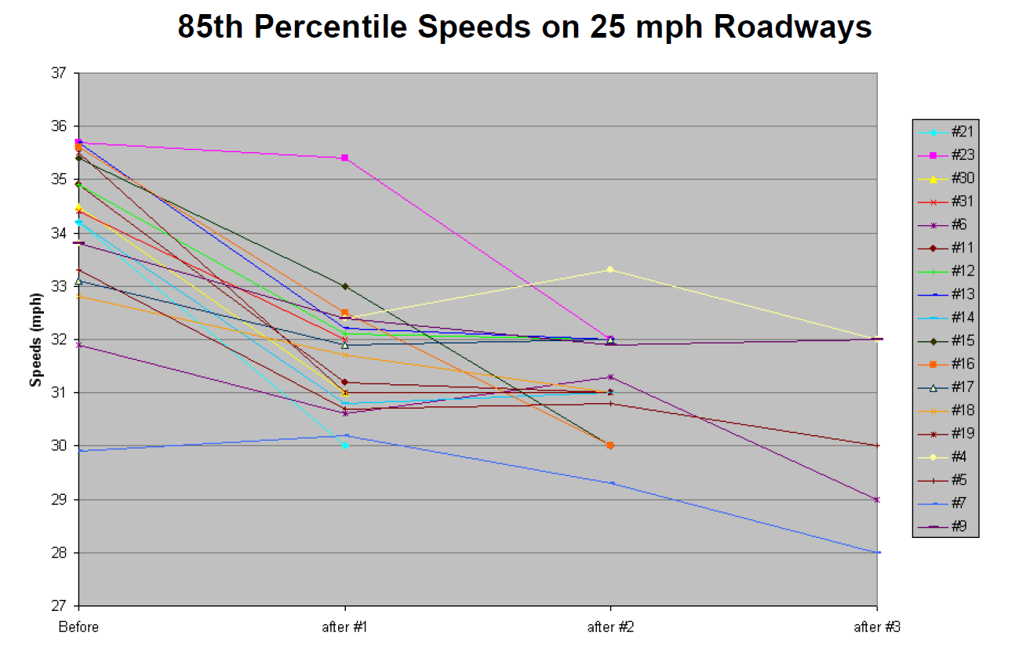

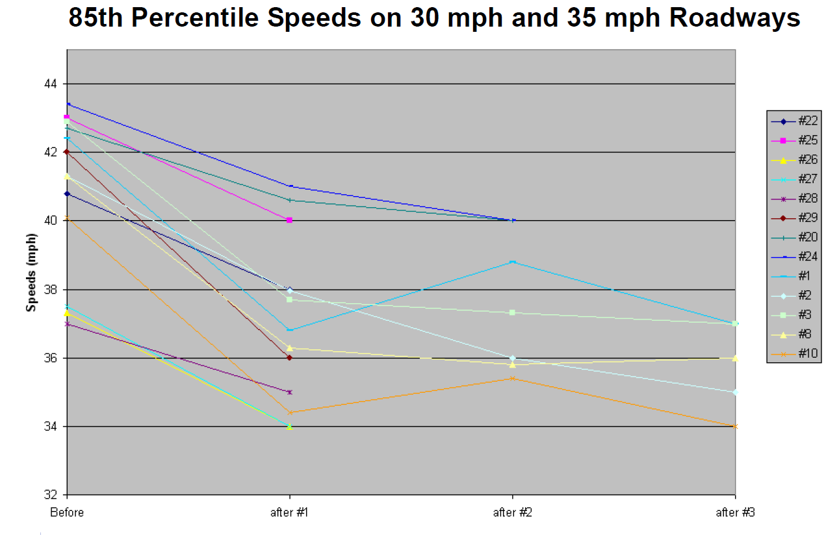Stationary Radar Sign Program, City of Bellevue, 2009 (assessment of over 30 sites and 85th percentile speeds)

To achieve these results more broadly, uniform sign design as proposed in the NPA is welcome and appreciated. However, there are errors in sign sizes shown in Table 2C-1 for vehicle speed feedback signs. For example, the W13-20aP cannot viably be provided with standard highway fonts that are visible in a 24 inch width (minimum 28 inches necessary). As FHWA produces the final rule, I would recommend that you design the Standard Highway Signs publication materials for each sign to refine the sizes – the minimum W13-20aP is likely 28” square. Attached is a W13-20 chart of examples to consider.

**Sections 2B.62 and 2C.68 (NPA Item #101): Photo Enforcement Signs**

Since the 2009 MUTCD, wider applications of automated enforcement has been applied in the USA. The NTSB in its report *Reducing Speeding-Related Crashes Involving Passenger Vehicles*, NTSB/SS-17/01, July 2017 makes several recommendations to FHWA related to automated speed enforcement. To achieve these objectives with the public sentiment that is wary of these systems, signs are necessary to avoid the perception of entrapment. Sections 2B.62 and 2C.68 provide some tools to address this need and the NCTUCD docket comments provide a bit more clarity by noting the application of photo/automated systems are not simply red-light running but include speed enforcement, railroad gate encroachment, toll avoidance, restricted lane entry to bus only facilities and other potential applications as the technology evolves. I have two questions for FHWA related to the signs in the NPA. First, there is a difference between jurisdiction-wide notification and site notification of automated enforcement. The question for site notification is whether it should be viewed as a warning sign (where W16-10P and W16-10aP might supplement standard warning signs such as W3-3 Advance Signal Ahead, W3-5 Reduced Speed Limit Ahead, W10-1 Grade Crossing Advance warning, W9-6 series Toll Plaza Warning) or their associated standard regulatory signs (using a R10-19P or R10-19aP)?

Secondly, the need to provide site notification of mobile/temporary automated enforcement is required in some states. Having a uniform sign for this purpose would greatly advance the application of automated enforce without the negative image of entrapment. An optional warning sign should be added. You may refer to the State of Oregon legislative requirements. The complexity for the future is where the automated enforcement does multiple functions (red light running, speed and lane intrusion enforcement). Please consider now, as options, sign flexibility to address these needs uniformly before ad hoc local and state sign applications are created to address this need resulting in erosion of public understanding and support of such systems. As greater experience with these devices is obtained, standards (in future MUTCD) could be considered based upon best practices. But please start now with sign uniformity to provide agencies the tools to help address the NTSB recommendation and address one of the most vexing issues in automated enforcement – the perception of entrapment.

**Chapter 2L (NPA Items #295-303) Changeable Message Signs/Electronic Displays**

Having co-chaired the NCUTCD Task Force on Electronic Display, I would strongly support the NCUTCDs docket comments to this chapter. The NPA was published in December 2020 just as the task force was concluding its work and gaining NCUTCD approval at its January 2021 meeting (incorporated by reference as NCUTCD Council item 20B-RW-03, approved January 20, 2021, attached – note changes are to the 2009 MUTCD in this document). Given the limited time to review NPA changes, the ability to rationalize all changes recommended in 20B-RW-03 approval in the NCUTCD docket comments was not possible, therefore the full work is provided to FHWA for consideration. I specifically wish to reinforce the NCUTCD docket comments related to definition of changeable message signs (Section 1C.02). A NCUTCD CAV Joint Task Force sub working group has reached out to both NEMA and ITE related to these definitions to seek consistency in definitions for both NEMA TS-04 (2021 which is under draft development) and NTCIP 1203 v.03. This includes CMS as the umbrella term with DMS, hybrid, blank-out and line matrix as various examples of CMS. There are subtle differences between the three documents and I would recommend FHWA work to seek reconciliation between all three documents (MUTCD, TS-4 and 1203) building upon the framework established by the NCUTCD.

Because some of the recommendations of 20B-RW-03 are included in the NCUTCD docket comments, I want to focus on just five aspects that time limited the ability to advance specific recommendations that I believe would enhance the final rule:

1. **Minimum Sizes for Lane Use Control Signal (refer to 20B-RW-03, page 58, Figure 4T-1a):** FHWA through official ruling (#4(09)-70(I) March 25, 2019 provided information that is not consistent with the technology in application related to the arrow indications and their appearance. Figure 4T-1a provides greater clarification separating the applications from high speed (freeway/expressways) from conventional roads and toll facilities. Please incorporate this graphic and associates edits as a part of Section 4T.03.
2. **Standard Highway Signs library of CMS fonts:** There is wide inconsistency in the state by state, agency by agency application of Standard Highway fonts on CMS/DMS in the USA. This is due to the lack of specificity in the appearance of these fonts. States leave vendors and in-house staff to (ad hoc) create what they deem best. If the MUTCD is to provide uniformity and consistency in the appearance for CMS, FHWA can assist greatly by simply developing a font library of characters using a 20 mm prototype for the key standard highway fonts used on DMS (Type E, D, C) for letter sizes that are common – 18 inch and 12 inch. NEMA TS-4 accomplished this for line matrix characters; however, appearance is a MUTCD function for sign legends and devices. These letter forms would provide industry and agencies an ability to be consistent and achieve the goal of “no apparent loss of resolution or recognition” (Section 2L.04 paragraph 21). Please include these alphabets/numbers/symbol characters in any updated Standard Highway Signs publication associated with the final rule.
3. **Flashing definitions.** In the 20B-RW-03 approval, definitions for flashing were created and approved. The recommended support statements may be best placed either in Section 2L.04 or Chapter 4S (pages 49 and 50). The option statements would be a part of Section 2L.04 (and if the definitions were placed in Part 4, a section reference would be needed). These definitions are needed to promote uniformity and consistency in application of emerging flashing operations.
4. **Diagonal Arrow/Streaming Chevrons.** Historically there has been substantial debate regarding the use of dynamic lane use control as a sign v. signal. The NCUTCD Task Force research of the industry indicated a chasm that separates FHWA definition from the vast majority of practitioners (survey of indicates 75% of the industry and 62% of the NCUTCD members indicated freeway lane use controls were “signs” not signals, refer to attached survey December 2017). This is because the application of lane use control for active traffic management is unique – it is not a reversible lane, simply warning of incidents and activity on the facility. These devices present controls in a series to warn rather than a single signal device that cycles through indications to control. Because of this mis-representation of definition to device, the types of displays that best can convey information to the traveling public have been restricted by lack of flexibility and a mis-interpretation of uniformity. Research has repetitively indicated that use of displays other than YELLOW X are better understood for warning and need to merge in advance of a lane use control signal. These alternative displays for advance freeway incident lane closure warning promote early merging and smoother traffic flow.

* Active Traffic Management: Comprehension, Legibility, Distance, and Motorist Behavior in Response to Selected Variable Speed Limit and Lane Control Signing, FHWA-HRT-16-037, June 2016, page 26-29 (streaming chevrons had 100% correct and diagonal arrow 90% responses as compared to merge/YELLOW X 3.5%)
* Pending research project NCHRP 03-123, which should be published prior to the final rule, will indicates best recognition of warning to merge out of a closed lane with diagonal yellow arrow. Information is available from:

<http://onlinepubs.trb.org/onlinepubs/nchrp/docs/NCHRP03-123_Task2TechMemo.pdf>

* WSDOT field application of diagonal downward yellow arrow demonstrates high driver comprehension and proper action associated with diagonal arrow displays in lane specific volume analysis. The follow graphics clearly displays the driver reaction to the downward yellow arrow message (shown locationally as the yellow line) for two separate incidents on I-5 in Seattle (one in lane 3 and the other in lane 4). The typical lane activity (shown in vehicles per minute per lane) are highest for the center three lanes in advance of the downward yellow diagonal arrow and drivers rapidly adjust (merge) to underutilized lanes to address lane the blockage/closure incident. Open lane utilization equalizes and lanes furthest from the incident lane increase the most to improve operational utilization of capacity and increase safety. The merging and reduced lane use happens well in advance of the incident (green line) starting ½ to 1 mile in advance of the DMS display of downward yellow diagonal arrow and stabilizes ½ mile after – well in advance of the incident (marked using Red X).

In Vancouver, WA where FHWA did not allow WSDOT to utilize downward diagonal yellow arrow for active traffic management, they also have data for using yellow X. Additional information will be shared regarding this performance as a part of another docket comment.

* Virginia DOT TRR research (attached): Dutta, Venkatanarayana, Fontaine, Effectiveness of Using Diagonal Yellow Arrows on Lane-Use Control Signals, Transportation Research Record, Journal of TRB No. 2654, 2017, pages 38-47 (which indicates downward yellow arrow was 6 times more informative than yellow X , more likely to be interpreted correctly in use as a freeway management tool and closes with “….indicates that driver comprehension of diagonal yellow arrow indication may be superior to that of the yellow X…”
* MNDOT limited simulator research also found diagonal yellow arrow to perform well: Investigating the Effectiveness of Intelligent Lane Control Signals on Driver Behavior, MNDOT Research Services, MN/RC 2012-22, August 2012, page 40.

The consistent findings of these research efforts points to the following findings:

* Downward diagonal arrow and streaming chevrons provide a more understandable **warning** to freeway drivers to vacant a lane that is controlled by a lane use control signal ahead.
* DMS provide the opportunity to display merge warnings **in addition** to “signal” displays related to incident lane closures
* Lane use control signals in this freeway setting are not the same as signal applications for reversible lanes

Based upon these findings, I would recommend that FHWA provide the following change to the NPA in Section 2L.04 as the new 6th paragraph, consistent with NCUTCD 20B-RW-03 to address the use of diagonal yellow arrow and streaming chevrons as a DMS (dynamic message sign – as defined in the MUTCD and per NCUTCD Docket comments) application to provide advance ***warning*** of lane closures/blockages as a part of active traffic management. The issue of the replacement of yellow X with such options should be subject to continued research, but for the 11th edition of the MUTCD these options (in addition to yellow X) should be provided based upon their extensive research, field application and road user understanding.

Option:

A downward diagonal yellow arrow may be used on a DMS in advance of the yellow X lane use control signal (see Section 4T.03), as an advanced warning sign of a potential lane incident/closure on freeways and expressways.

Displays using coordinated flashing may be displayed for the following:

1. Temporary traffic control advance warning arrow boards that use alternating, sequential or streaming displays (see Sections 6F.60 and 6F.61) or their CMS equivalent;
2. A series of Chevron Alignment signs (see Section 2C.09) sequentially or their CMS equivalent;
3. Rapid flash beacon or their CMS equivalent (see Chapter 4S); and
4. Advance warning of potential lane closure/blockage on freeways and expressways using streaming chevrons on a DMS (similar to W1-8 and Section 6F.61) ) in advance of the yellow X lane-use control signal (see Section 4T.03) as lane change direction warning.
5. **Lane Use Control Signal Visibility 2,300 v. ½ mile:** Parts 2 and 6 of the MUTCD utilize ½ mile visibility for the same thing that Section 4T.03 states as 2,300 feet. Refer to pages 5 and 59 of 20B-RW-03. This inconsistency is not corrected in the NPA and not reflected (due to time) in the NCUTCD docket comments. Change 2,300 feet to ½ mile for uniformity in Section 4T.03.

**Sections 2D.47/2D.55/2I.02 Publicly Accessible Off-Street Parking Signs**

Following the publication of the NPA in December 2020, the NCTUCD Council approved item 20A-GMI-01 on January 19, 2021. Due to the extensive amount of NPA review, this new material was not able to be provided in the NUCTCD docket comments. It is provided here as a recommendation for FHWA to consider, including detailed text edits to the 2009 MUTCD for reference. The text proposals are principally options. Given that this sign proposal is extensively utilized in the USA (and the world), is similar in context and nature to the NPA content (and is a part of sections referenced in the NPA by items #174 and #180) and would not affect any existing signs unless replaced, built new or at the end of their service life, it is asked that this proposal be incorporated into the final rule (see attached 20A-GMI-01). There is substantial documented research demonstrating the application of this sign is well understood and the need for uniformity is critical now so further variations do not erode the benefits of consistent and uniform displays in providing target value to both drives and automated vehicles.

**Sections 2B.18 & 3B.21 Site Roadways Open to Public Travel and STOP Pavement Marking**

After leading an extensive collaborative effort to consider the impacts of the federal rule making that makes site roadways open to public travel subject to the MUTCD as a task force of the NCUTCD (resulting in 15A-EC-01, approved January 8, 2016), I applaud FHWAs broad incorporation of this recommendation and specifically the decision to delete the first standard text in Section 3B.21 related to parking lot use of STOP pavement markings. I support the NCUCTD docket comments that address several of the recommendations that were not included as part of the NPA. Specifically, I would recommend that in Sections 2B.18 (added as the last sentence to the last option following the NCUTCD Docket recommendation) & Section 3B.21 (following the first standard statement, paragraph 3) that a new option statement be added consistent with NCUTCD Council approval 15A-EC-01. To address the complexity of site roadways and the interface between circulation roadway that are controlled by the MUTCD and parking aisles, providing an option for pavement markings without stop signs as a safety related feature of controlling right-of-way. This has been commonly done for decades in these settings providing clarity of right-of-way for safety where the use of stop signs is excessive and not necessary. These locations are commonly low speed, 25 mph and less, if FHWA wished to add the qualification, that would be acceptable.

Section 2B.18

Option:

At the ends of driving aisles connecting to site roadways open to public travel, the word STOP on the pavement when accompanied with a stop line may be used in the place of a STOP sign.

Section 3B.21

Option:

At the ends of driving aisles connecting to site roadways open to public travel, the word STOP on the pavement may be used in the place of a STOP sign when accompanied with a stop line.

**Section 4F.19 Pedestrian Change Interval Violation**

In NPA Item #414 the permitting of pedestrian change interval is very troubling and not safe for pedestrians. Violation pedestrian change interval does NOT improve safety of pedestrian. Trains and ships do not pop out of nowhere and their presence and need for preemption can be anticipated, scheduled and detected appropriately. Congress has demanded automated train control and these systems would assure the safety of pedestrians through advanced detection and preemption techniques. It is not FHWAs job to determine when and how they accomplish preemption and detection any more than it does for all DOT for all the other changes in the MUTCD. The following changes are recommended for Section 4F.19, standard item C:

**Standard**

**C. The shortening or omission of ~~any~~pedestrian change interval shall not be permitted. ~~only when the traffic control signal is being preempted because a boat is approaching a movable bridge or  because rail traffic is approaching a grade crossing.~~**

*Guidance:*

*The shortening or omission of any pedestrian change interval should only be considered when the traffic control signal with little or no pedestrian activity is being preempted because:*

1. *a boat is approaching a movable bridge without communication, or*
2. *rail traffic is approaching a grade crossing and other options are determined to be impractical by a Diagnostic Team (see Section 8A.01)*.

**Section 4P.02 Ramp Meter Signals**

The NPA item #435 changes the display of two-lane ramp meters to require two signal faces per lane (6th paragraph to Section 4P.02). There is no research in this setting of safety benefits from in-field application of well-designed single face per lane ramp meters. This is an unnecessary and an economic burden to multi-lane ramp meter operations across the county. LED displays eliminate the issue of dark signal displays. I support the NCUTCD docket comments to this paragraph.

**Treatment of Pedestrian in the MUTCD**

There are over 1225 mentions of pedestrians in the MUTCD NPA and over 230 mentions in NPA website. The importance of pedestrians as a road user and the associated traffic control devices to serve them is certainly not lost in the MUTCD. However, our industry performance in improving pedestrian safety over the time since the last MUTCD update is not adequate. Advancing the NPA as soon as possible to final rule making, taking consideration of comments such as those from ITE, NCUTCD and those noted below can be done without delay. These comments address many of the very issues raised by repetitive comments to the NPA Docket requesting “rewriting”. While many have requested “reframing” the MUTCD now, the lost time would mean lives lost in not making the safety enhancements proposed in the NPA readily available to practitioners. The further “reframing” can be a discussion for more timely updates following final rule making of the 11th Edition of the MUTCD.

Pedestrian fatalities and serious injuries have been growing as a share of total fatalities and serious injuries in the past decade. With nearly 6,600 pedestrians killed in motor vehicle crashing in 2019, it is the largest number of fatalities dating back to 1988[1] (this averages one pedestrian fatality every 80 minutes). A factor in providing safer pedestrian travel is pedestrian traffic control design which involves signing, markings, signals, temporary traffic control, and school areas. Given the heavy attention to vehicle needs within the MUTCD, there are gaps in understanding pedestrian traffic control, proposal initiation and review related to pedestrian needs. Simple organization efforts focused on pedestrians would better advance pedestrian safety needs through focus on traffic control devices that benefit pedestrians of all ages and abilities. While more research is needed in the area pedestrian safety on roadways (particularly in the selection of crossing devices to address context, characteristics and users), a great start would simply be organizing the array of MUTCD pedestrian devices in its three primary parts (signs, markings and signals) to bring added attention to pedestrian traffic control. This would not be new content, just better organized content. Below is a sample of how this could be done using the NPA without major changes. This would allow greater attention to pedestrian issues and build focus following the final rule as to how to enhance these sections/chapters in any subsequent (timely) updates.

**SIGNS**

Create a new chapter in Part 2 for “Pedestrian Signs” (best if it were 2D but that is discretionary). It would consist of a combination of moving sections outright to the new chapter and cross references (as noted below). Appropriate references would remain in Chapter 2B and 2C to say “(see Chapter 2X)” to provide cross reference for existing Chapter 2B and 2C users.

|  |  |  |
| --- | --- | --- |
| **2B SECTIONS TO MOVE:**  Sections 2B.19 & 2B.20  Figure 2B-2  (noted as NPA items #65 & 66) | Sections 2B.57-58-59  (noted as NPA items #97 & 98) | Section 2B.60 – only text related to R10-15 signs (replace with a cross reference to Ch. 2X |

References would be made to Section 1C.02 for pedestrians definitions, Chapter 2A for general sign information related to pedestrians, Sections 2B.06-2B-10, 2B.12, 2B.16 & 2B.17 when considering stop or yield signs in relation to pedestrians, Section 2B.21 related to speed limits, Section 2B.46 for pedestrian exclusions, and 2B.61 for NO TURN ON RED. These sections would include minor description of the circumstances with the cross-referenced section.

|  |  |  |
| --- | --- | --- |
| **2C SECTIONS TO MOVE:**  Section 2C.54 – only text related to W11-15 signs  (noted as NPA item #149) | Section 2C.55 – only text related to W11-2 signs | Section 2C.56 |

Cross reference Sections 2D.45 related to street name signs being visible to pedestrians, 2D.55 related to community wayfinding,

**MARKINGS**

Markings already has a chapter devoted to pedestrians in the NPA. Chapter 3C should be renamed “Pedestrian Crosswalk Markings”. Within Chapter 3C, cross references should be made to Sections 3B.19 (for stop/yield line marking), 3B.29 (for raised pedestrian markings), 3H.03 (for aesthetic crosswalk markings) and 3J.07 (for curb extension markings).

Further, the chapter organization of Part 3 would be enhanced for MUTCD users if it were realigned as noted below using consistent/uniform titles for each chapter ended with the word “markings” as shown below:

3A. General

3B. Pavement and Curb Markings

3C. **Pedestrian** Crosswalk **Markings**

3D. Circular Intersection Markings

3E. Delinators (move this chapter here to allow Chapters 3F and 3G to match chapter designations with Part 2 (2F and 2G)

3F. ~~Markings for~~ Toll Plazas **Marking**

3G. Preferential Lanes Markings for Motor Vehicles (move 3G Delineators above)

3H. Channelizing Devices Used for Emphasis of Pavement Markings ~~Patterns~~ (retain 2009 chapter designations from here on down – move all colored pavement material to Section 3A.03 “Colors” where it is better referenced and placed and eliminate redundant text)

3I. ~~Marking and Delineation of~~ Island and Curb Extension **Markings (NOTE: if the decision is made to create a new Chapter 2D: Pedestrians Signs, move this chapter to the 3D position to re-sequence marking chapters to align with Part 2 for tolls and preferential lanes – as this chapter is closely aligned with pedestrians)**

3J. Rumble Strip Markings

**SIGNALS**

The core content of pedestrian signals all exists in the NPA. To organize it for best user application all the pedestrian signal chapters should be moved to the end of Part 4 and a short new Chapter added “Pedestrian Signals – General” as an introduction to the following five chapter (to be placed in sequence at the end of Part 4):

* Chapter 4X Pedestrian Signals – General (new)
* Chapters 4I Pedestrian Control Features, NPA #419-424;
* Chapter 4J PHB, NPA #425-428;
* Chapter 4K Accessible Pedestrian Signals, NPA #429-431;
* Chapter 4L RRFB, NPA #432;
* Chapter 4U In-Roadway Warning Lights, NPA #446-447

The new “General” chapter would introduce the five subsequent chapters and provide cross reference to the following sections:

* Signals – Section 4D.02, #418,
* Section 4D.02 Provision for Peds
* Warrants – Section 4C.01 Studies, Sections 4C.05 Ped Volume(5), Section 4C.06 School Crossing (6), Section 4C.08 Crashes (7)
* Section 4B.01 General
* Section 4B.02 Basis of Installation
* Section 4B.04 Advantages and Disadvantages of Traffic Control Signals
* Section 4B.05 Alternatives to Traffic Control Signals
* Section 4A.08 Use of Signs at Signalized Intersections
* Section 4A.06 Meaning of Pedestrian Signal Indications
* Section 4A.04 Meaning of Flashing Vehicle Signal Indications
* Section 4A.03 Meaning of Steady Vehicle Signal Indications
* Section 4A.02 Meaning of Signal Indications

Finally, in Section 4U.01, NPA Item #446, support statement – Add “wide roadways (commonly greater than 5 lanes two-way, greater that 3 lanes one-way)” to the 2nd sentence as the first example.

**Treatment of Buses in the MUTCD**

Similar to pedestrians, there are numerous mentions of Bus and transit in the MUTCD. While less than pedestrian (bus/transit mentioned 320 times in MUTCD and 30 times in NPA items) the content necessary for designer to uniformly address bus/transit solutions in the MUTCD is scattered and limited. The NPA makes significant attempts to address these shortcomings which is appreciated. The NCUTCD Task Force on Bus/BRT Traffic Control completed a three-year effort on January 2021 (after the NPA was published) which was approved by NCUTCD Council as 20B-RW-02 and is attached here for reference. While the task force was unaware of the NPA approach at the time, it recommended new sections to Chapter 2B for Bus Lane Regulatory Signs and applications (graphics), a new section to Chapter 3D for Bus Lane Markings and edits to Parts 4 and 8 related to signals and railroads.

The time to complete a full review of the NPA and address this recent approval was not possible in the NCUTCD docket comments. I am providing these comments for FHWA to consider the incorporation of the extensive multi-disciplinary, multi-technical committee research and collaboration effort in the NCUTCD item that led to approval January 19, 2021. Upon reviewing the NPA, the concepts of 20B-RW-02 are addressed in NPA items, just slightly differently. The following recommendation are proposed to FHWA for consideration:

While the proposed Section 2B.23a (which would be Section 2B.34a in the NPA numbering) was placed in Chapter 2B, it could equally be integrated into the NPAs new structure for Chapter 2G with a sub-heading of “Bus Lane Signs” following new Section 2G.15 (prior to the “Managed Lane Signs” sub-heading). There would need to be some rationalization of text between the proposed 2B.23a & 2B.23b text and the NPA’s new text in related to part-time travel on shoulders in Sections 2G.20, NPA #250 (general), Section 2G.21, NPA #251(regulatory signs) & 2G.22, #252 (warning signs) & 2G23, #253 (guide signs) & 2G.24, #254 (lane-use control signals) to avoid redundancy in final edit. The key is the graphic with proposed bus-focused signs and the bus lane applications graphics.

For markings, the proposed Section 3D.01a “Bus Lane Markings” could be placed in the NPA following Section 3E.03 (proposed above to become 3G.03). It would be recommended that the NPA Chapter 3H be incorporated in Section 3A.03 and the red colored pavement text is minimized as noted in 20B-RW-02 on line 965.

For signals, it is recommended that the new Section 4D.03a be added after the NPA sections on provisions for pedestrians and bicyclists. Additionally, the proposed new Section 4F.17a Bus Traffic Control Signals should be added at the end of NPA Chapter 4F as a new “Section 4F.21 Signal Indications for Bus in a Separate Signal Face” following the NPA sections on Preemption and Priority Control of Traffic Signals.

**Docket Letter Writing Campaign Response**

The Docket has been filled with a form letter with the same five points. Many are addressed in my comments. I would caution FHWA from delaying the update of the MUTCD to “rewrite” it and would respond to these comments as follows:

1. Speed Limits: The NPA narrows (properly) the perspective of the 85th percentile to freeways and rural highways, improving upon the 2009 MUTCD. The NCUTCD studied the NTSB recommendations and offered details in Council approval 18B-RW-03 that the NPA mostly incorporated. “No longer use” belies research in its application on higher speed facilities. Do not agree.
2. Signal Warrants: Warrants are not the only consideration of installing traffic signals. While research may identify updated information (such as was completed with the stop signs in this NPA) it is not available today and the NPA should not be held up to wait for such research. Do not agree.
3. Shall Statements: While the NPA has numerous standards, they do not preclude the safe treatment of bicycle and transit infrastructure if taken in their proper context. Do not agree.
4. Urban Context: The NPA, along with comments offered above and by ITE and NCUTCD address this topic adequately. For lower speed facilities (25 mph or less) there is flexibility. However, higher speed roadways create safety circumstance that require study. Is a study to assure the application is appropriate to context, characteristics and users a barrier? Do not agree.
5. Cost Burden: Is the documentation of before and after circumstances too large a burden to the traveling public to demonstrate safety benefits? Where research has been completed and shown in a range of applications (not one project, one city, one location, siloed research), FHWA has been open to changes to the MUTCD (witness the hundreds if not thousands of changes in 2009 and in the NPA). Do not agree.

1. Pedestrian Traffic Fatalities by State, 2019 Preliminary Data, GHSA, February 2020.